Conf+

Technical documentation

Matthew boroczky  
Michael Kong  
Loo yee liew  
ruixi HE  
Chee Yeong Lim  
Sandon Joubert  
junyan fan

2015

Table of Contents

Preamble 4

System Overview 5

Vision 6

Glossary 6

Problem statement 7

The problem: 7

The affected: 7

The impact: 7

The solution: 7

Position statement 9

Target Market: 9

Unlike competitors: 9

Our Product: 9

Marketing and advertising 10

Advertising and Marketing Strategy 10

Competitors and alternatives 12

System Structure 13

User environment 14

Scope and limitations 15

Constraints 15

Cost and Pricing 15

Quality Ranges 17

Procedures and Priorities 17

Documentation Requirements 18

Operational requirements 18

Technologies 19

Software 19

Development Tools 20

Hardware Specifications 21

Front End Specifications 21

Back End Specifications 21

System Architecture 22

Sub-system Relationship and Interaction Diagram 24

System Flows 25

System User Interface Design 28

Website Design 28

Mobile Design 32

Database Design 38

Database Schema 38

Data Dictionary 38

Third-party Libraries 44

Testing Plan 46

Testing inaccuracy 46

Techniques 46

Future development 47

Sensitivity 47

Assertion 47

Test cases 48

Black Box and White Box Testing 48

Testing tools 49

# Preamble

This document records the technical information that pertains to the Conf+ Conference Management System. All information within this document is primarily written for future iterations and developments, so that other developers and interested parties may be able to understand the structure and technical intentions of this system. lnformation within this document is preliminary and subject to change.

# System Overview

Conf+ is a conference and event management system that is seeking to integrate event organization capabilities, conference paper reviewing and in-event support. Conf+ delivers an online web application and iOS mobile application that encompasses these capabilities to provide a guided process from event creation to in-house support.

The system includes features such as booking ticket, seat selection tools, seat release criteria, assigning speakers to rooms in a venue as well as an entire venue builder tool allowing the drawing of the venue without the use of third party applications.

Conf+ allows users to create events and conferences. The difference between events and conferences is that conferences open paper reviewing features to the event organizer. In the paper reviewing features, users in the system who are skilled in particular areas can be invited to review relevant papers ensuring the integrity of the reviewing process. The paper management features will include reviewing features on papers, manual and automatic checking of conflict of interest, customer setting options such as determining minimum and maximum difference in papers reviews and much more.

The system also features a venue builder that allows users to build and design venues. Once the venue is created, it can be reused by other future events and conferences. Pictures, maps and available resources can be added to each created venue in the system to assist event organizers in choosing the right venue for their events.

Conf+ will also be providing functionality to be used within the event itself such as: a mobile app that contains a map, has the ability to locate others and add them on LinkedIn and Facebook, has the ability to alert security if attendees are in need, has the ability to use phone ticketing system (iOS Passport) to hold ticketing information on phone and allow creation of a personalised timetable to sort out different performances/presentations.

These are just are few of the features we will provide that will allow us to cover a broad target market by covering numerous functionality and eliminating the need to use multiple application for the smooth running of the event. "We are with you step by step from the creation of your event to intra-event maps and timetable through to the post-event financial analysis and statistical accumulation."

# Vision

Conf+ is a tool we envisage as being a complete tool for both conference organising and events. Other tools are proficient at either conference management in terms of papers submission & review .etc, other tools such as event organising tools are proficient at the managing and organising of upcoming events. Conf+ combines these two worlds and more. Not only are we concerned with the planning of conferences and general events but we are also concerned with ways we can improve the experience of event and conference attendees.

# Glossary

**Event Organiser** - Individuals at the top of the hierarchy within the event. They have the ability to create and change all details about the event.

**Conference** - a formal meeting for discussion. When considering conferences, the system is not limited to small academic conferences. It should support the management of large conferences such as Apple’s WWDC conference in which thousands attend (~ 5000)

**Event** – An event is similar to a conference but has functionality for paper reviewing is disabled.

**Session** - Sessions are held within conferences or events. One event/conference must have one or more sessions.

**Author** – Refers to an author of a paper. Also refers to event speakers since authors are potential speakers.

**System** – Refers to the Event Organiser and its subsystems.

**User** – Refers to any user of the system.

**COI** – Conflict of Interest

# Problem statement

## The problem:

It is difficult to find a tool that covers a large basis of planning, management, organisation and review of Conferences and general events, and covers it well.

Each application only covers at most one part of conference/event management, organisation and review (MOR) well, or covers and even spread across majority (not all) of areas involved in conference event MOR but does not cover it well enough/in enough depth/have a low level implementation. An example of this would be a software providing the ability to purchase tickets and ticket type but not having the ability to select seats using a GUI or having seat release conditions to ensure the company doesn't lose seats and profits. "Your profit is our profit, we both desire to optimise all aspects."

## The affected:

Event and conference organisers, individuals wanting to create an event, event/conference attendees, event/conference presenters/performers, the public looking at attending an event.

## The impact:

Companies would hire developers to create a venue on their website with seats and seat types to enable customers to be able to select seats for their venue. They would then have to use another third party software to manage the event and ticketing; an example of this would be EventBrite. Another third part software must then be used (such as EasyChair or ConfTool) to allow the conference proceedings such as paper submission and review to be allowed. Additionally no management tools, (such as EventBrite),(from our understanding), have the ability to purchase tickets for events and select the attending performances as there may me concurrent performances/presentations at one. In addition to this timetabling of the event is being provided. These tools are not provided by software we have found and therefore we can conclude developers would need to be hired to implement this functionality. Finally we must consider that developers may possible need to integrate these system, although some may be able to be used separately, integration is desirable to increase usability and efficiency, however this will incur greater costs from the company.

## The solution:

1. To hire developers to Develop and integrated software solution and host it on the company's server.

2. Another solution would be to pay for all third party software and use it stand alone (note: some functionality will not be provided)

3. Another solution would be to pay for all third party software and pay developers to integrate the third party applications to achieve an integrated system (note: some functionality will not be provided)

4. The final solution . would be to pay for all third party software and pay developers to integrate the third party applications to achieve an integrated system and to get developers to build the functionality not included in the third party applications.

# Position statement

## Target Market:

Event and conference organisers, individuals wanting to create an event, event/conference attendees, event/conference presenters/performers, the public looking at attending an event.

## Unlike competitors:

Unlike ConfTool and EasyChair we plan to have our services available online and we will not limit ourselves to just paper reviewing and general conference management.

Unlike EventBrite we will provide advanced features such as seat selection, seating release conditions and a venue building tool. We will also provide a in-house system which will allow timetabling, networking and security measures to be in place.

## Our Product:

Conf+ will be using the Software as a Service (SaaS) model which will reduce the need for the software to be installed locally on their servers and eliminate them to pay for the entire software outright. Using SaaS will reduce their upfront payment (to nothing) and increase our profitability (the ones hosting the software) as we will require a dividend on the purchased ticket prices. This will also allow our software with limited functionality to be used for free with events that have free tickets and less than 200 capacity for the event (for events not conferences). In return we will offer our Conf+ which integrates functionality that would usually require numerous third party software to be used. Not only that but we do not only strive to cover a spread of functionality but to cover each functionality well to ensure the highest degree of practicality and usability.

# Marketing and advertising

Marketing and advertising is a very important aspect of any product. A product may be really good but if it does not have good advertising, the product may fail.

Conversely, a product which may not have many significant advantages over other similar products, but has a good marketing campaign, can lead the product to success.

Hence, we believe marketing and advertisement is important. Below is a list of our marketing and advertising strategy.

## Advertising and Marketing Strategy

1. Target market  
   This is the important part in Marketing Strategy, because every strategy needs to understand the target market. We are targeting event organizers, academic and industry professionals, and the general public. Event organizers will be one of the main targets because they will be creating the events for participants to join. Academic and industry professionals will be the leading group in the conferences because they would include people at the forefront of major technological developments and research. The general public is another target group because this group will be the core attendees of any event.
2. Marketing methods  
   The number of users who will use our system is a good indicator to evaluate whether our system is successful or not. To attract users, we have a list 3 methods:  
   1. Limited free trial. New users can experience 3 months of free trial on our system. This will give them time to explore, learn and get familiar with our system.
   2. Hunger marketing. We create an advertisement that states if the user upgrades their membership within the 3 months of limited free trial, you can they will get an extra 1 year membership for free. This method attracts users to invest in our system for a longer period of time.
   3. Building a good brand image. Brand image is important for a new product because a good brand image promotes the integrity of the product. Therefore, people are more willing to trust products with a good brand image. To build a good brand image, we can cooperate with established enterprises because such enterprises have good brand image. Therefore, if established enterprises use our product, people will view our product as trustworthy.
3. User retention  
   Products are made to serve people. If the service that the product provides is lackluster, users will not use our product. We list two strategies to retain users:
   1. Product improvement. Since Conf+ is a software, existing features will continually improve and new features will be developed. These will assist in user retention to meet the current needs of users.
   2. Loyalty programs. If a paying user has used our product for 2 years and has created 10 events within that time span, he can get discount in for the next year’s membership or he will get point which instead of some money to attend some events.
4. Attracting users to upgrade to a paid account  
   A balance the free functionality and paid functionality is key. If the free functionality provided allows the user to perform all tasks within the system, they will not find the need to upgrade. However if the free functionality stifles the user’s ability to experiment with our system’s basic functionalities, they will not use our product either.

# Competitors and alternatives

As with any product, we have competitors and alternatives. If we want our product to stand out, we need have an edge over the other competitors. The following list contains the three most popular competitors and an analysis on their advantages and disadvantages.

1. Eventbrite  
   Eventbrite is a website that allows people to find and create events in different countries. Being a popular event management system, it has many comprehensive event features. However it does not have strong support for conferences which require paper reviewing and validation. Conf+ has an advantage over Eventbrite here because we have features to support both events and conferences.
2. Easy Chair  
   This is a conference manager system that has support for paper reviews and validation. While It is a good conference manager, it has some disadvantages:  
   1. Lackluster user interface. When users first enter the Easy Chair website, there is nothing attractive about the site due to the plain pastel colour scheme.
   2. Requires download and installation. Since the emergence of software as a service (SaaS) delivery models, many users prefer systems which require no installation and convenient access. While Easy Chair does allow users to host the Easy Chair software on their own servers, it does not provide the convenience of SaaS delivery models which Conf+ will be following.
3. Conference Alerts  
   This website is a conference aggregator and web portal. Users can find many different conferences on this website, however when users select a conference they will be redirected to a webpage that list basic info about the conference and a web link to an external web page for that particular conference. So conference alerts is simply a web portal for conferences so there is no real conference creation capabilities on this system.

In conclusion, we have the following advantages over the aforementioned systems:

1. Conf+ has features to create both events and conferences, giving users the flexibility to choose a basic event or a more sophisticated conference.
2. By focusing on UI and UX design, we aim for an aesthetic and usable system and web application.
3. Deploying Conf+ as a SaaS, users have the capability to access our system from desktop or through the mobile application.

# System Structure

The structure of the system can be broken down into 4 distinct components:

* Online website  
  The main interface of the system. It consists of a series of webpages that allows the users to access the features of the system. All features are available on this component except the in-house subsystem which will be handled in the iOS application.
* iOS Application  
  The secondary interface of the system. It is a mobile application that provides a subset of the features available on the webpage such as purchasing a ticket for an event and managing user profile. The iOS application will also have additional functionality by providing the user with an in-house subsystem which provides features such as providing venue maps and check-in services.
* Application server  
  The application server is the intermediary between the database server, the iOS application and the online website. It performs inserts and updates on the database when users add or change items on the website or iOS application. It also performs queries on the database, processes the data and returns the result to the website or the iOS application.
* Database server  
  This component stores all the data that is considered persistent in the system, such as user emails, submitted papers and event details.

# User environment

The user environment for the system is the standard ADSL internet connection, web browsers such as Google Chrome, Safari, Firefox, Internet Explorer etc. To support web browsing on personal computers and laptops, operating systems namely Unix, Microsoft Windows, OS X and Linux will act as the fundamental operating environment.

In this project we will be developing a mobile application complimentary to the system, the mobile platform chosen is iOS. Network connection for the mobile device is also essential for downloading the application and using it for real-time updates.

Lastly, e-mail access is also required in order to fully utilize the notification functionality of the system. Users may need to have an active existing e-mail account or will be asked to create one.

# Scope and limitations

The team will be using Amazon Web Services (AWS) for server side services. AWS offers a broad set of global computation solutions, storage solutions, database solutions, analytics solutions, application solutions, and deployment services that help organizations move faster, lower IT costs, and scale applications.

As the AWS calculates cost and pricing by every input and output, the development team has to minimize interaction with the AWS during development. Developers have to run the test servers on their local machines for testing and fixing bugs. When features are tested and debugged, the team will push those features the server.

Although there are 7 members in the team, the team lacks experienced in back-end development. Therefore, it is a challenge for the team to develop a scalable, maintainable and efficient system.

## Constraints

The Event Management system and its requirements are limited by the following constraints:

* Network - The performance of the system is dependent on the performance of the network connection it is on. The requirements defined in this document assume a standard ADSL network connection.

## Cost and Pricing

* Cost for user

The Event Management system will be available for free to the general public. However, the system will also provide a paid subscription service, where a user will pay a small amount of monthly fee to access additional features of the system, such as:

1. Creation of new events
2. Making use of the Conference Management features (e.g.: paper submission and paper reviewing)

As the system is not being marketed as a product, there will be no additional charges (such as licensing) to potential vendors.

* Cost for owner

AWS offers a simple, pay-as-you-go pricing approach for over 40 cloud services. With AWS the team will only pay for the services that the team needs. Since there are no long-term contracts, the team does not have to worry about  dependencies, complex licensing or termination fees.

AWS offers cloud services with a free tier available for 12 months. On a monthly basis on the free tier, the services that the team will be using are,

1. 750 hours of EC2 instances with 1 vCPU and 1 Gigabytes of RAM;
2. 5 Gigabytes S3 standard storage with 20,000 get and put requests;
3. 750 hours of RDS instances with 20 Gigabytes storage and 10 million Inputs/Outputs;
4. 1 million API calls;
5. 750 hours of Elasticsearch instances.

The aforementioned specifications are sufficient for the team to run the project for one year unless there is an exponential growth of users for the project. Different services will have different pricing schemata. For example, if the project is too large for the free tier EC2 compute engine, the team will have to pay USD 0.02 per hour* for better server instances, or if the 5 gigabytes of storage is not enough to store all the papers and other files, the team will need to pay USD 0.03 per gigabyte for extra storage for the first terabyte*.

The cost and pricing of AWS above is correct as of 30 September 2015. The price might change as the follow the Moore Law, the price for cloud services will decrease dramatically over time. It will be more suitable to refer to the pricing sites in AWS sites all the time.

*More information about pricing for AWS can be found at: https://aws.amazon.com/pricing/services/

# Quality Ranges

The following points describe the quality ranges and expected performance benchmarks for the Conf+ system:

* Availability – The service will be available 24 hours a day, 7 days a week, with 2 hours downtime a week during non-peak hours for scheduled maintenance.
* Usability – The service will be easy to use for both novice users, who are expected to have only small amounts of technical knowledge, and for the expert users, who are expected to have good understanding of the system and its components.
* Maintainability – The system is easily changed and configured without the need to reconstruct or redeploy the system.
* Accessibility – The service will provide help for the users, in forms of online help and user and administrator manuals.

For additional quality ranges can be found in the Non-Functional requirements section of the Requirements document.

# Procedures and Priorities

First of all, the team will design the application web interface. Using the created interface, the team will determine the data required to be stored in the database. After most of the requirements for the web is complete, the team will start development on the iOS application because it is an extended feature of the whole system and not a core component of the system.

The team will first focus on core requirements, and then move on to main requirements. The team will also try their best to implement requirements in stretch goals and dream goals. Details on the priority of the requirements and the order they are to be implemented can be found in the Software Requirements Specification document.

# Documentation Requirements

The following documents are required for the full system release:

* Technical Documentation – This document describes the development process and the structure of the system. With this document, future developers are able to understand the system’s technicalities and make changes to the system.
* User Manual – This document serves to help users understand certain parts of the system that may have a complicated process and describes features that not all users might not use on a daily basis. A downloadable copy will be available from the Conf+ website.
* Online Help – This help is provided in two ways. Firstly, it is a set of FAQ’s on the Conf+ website or the Conf+ mobile application. Secondly, help is also provided via tool-tips, icons and a standard interface on the Conf+ website and the Conf+ mobile application.

# Operational requirements

To access the Conf+ website, users must meet the following requirements:

* Web browser
* Network connection

To access the mobile application, users must meet the following requirements:

* iPhone or iPad running on iOS 8 and above
* Network connection

Optional/extended operational requirements:

* Printer to print self-print tickets or details on events for reference
* Label printer for organizers to print event labels
* QR scanner to scan user’s QR code tickets

# Technologies

## Software

* PHP – PHP is an open-source, server-side scripting language. This language is used in Conf+ because it is one of the most used server-side scripting languages. Therefore, help resources online are widely available. In Conf+, PHP will be used for three main purposes: processing data that was queried from the database; storing given data into the database; and tracking user sessions.  
    
  Reference: http://php.net/
* SQL – Stands for Structured Query Language. This is a default query language for many databases available. Conf+ will use this query language to pass data between the PHP scripts and MySQL database.
* MySQL – An open-source relational database developed by Oracle Corporation. This software provides powerful database capabilities that enable it to rival systems such as Oracle and DB2 in terms of features. Although MySQL may not have the processing capabilities of more powerful systems such as Oracle and DB2, it is a sufficiently good, open-source system for use in the Event Organizer.  
    
  Reference: https://www.mysql.com/
* SQLite – This is a popular embedded database that will be used in the Conf+ iOS application. The embedded SQLite database will be used to store data that is personal to each device such as user name and ticket details.  
    
  Reference: https://www.sqlite.org/
* HTML5/CSS3 – HTML5 and CSS3 are the new standards for web development since 2014. HTML is a markup language used by web browsers to render content and CSS is a style sheet language used to define how the HTML markup is presented.
* JavaScript – A commonly used programming language in website and web app development. It is supported in many web browsers natively and it is used to dynamically manipulate the Document Object Model (DOM) of HTML documents and the CSS styles of web pages.
* JSON – JSON is a data structure that is lightweight and supported by many programming languages. It is commonly used as a means of interchanging data between applications. In the Event Organizer, it will be used as a means of communicating between the web client/iOS application and the application server.  
    
  Reference: http://www.json.org/
* Objective-C – A programming language largely used in developing OS X and iOS applications. Currently there are many Objective-C libraries written specifically for iOS applications which reduces the amount of time in writing and testing code.
* Swift – A programming language developed by Apple Inc. for developing applications for iOS, OSX and watchOS. Since Swift’s language syntax is simpler than Objective-C’s, Swift speeds up application development time. Furthermore, it is cross compatible with Objective-C, which gives Swift applications access to existing Objective-C libraries.   
    
  Reference: https://developer.apple.com/swift/

# Development Tools

The following development tools will be used in the development of Conf+:

* Google Chrome for web
* Mozilla Firefox for web
* Sublime Text
* Xcode IDE for iOS
* GitHub versioning system

# Hardware Specifications

## Front End Specifications

Organizers

* QR code scanner
* Label printer

Users

* Personal computer
* Laptop
* iPhone
* iPad
* Printer

## Back End Specifications

***Host***: Amazon RDS (database services)

***Usage***: Managed Relational Database Service for MySQL, Postgres, Oracle, and SQL Server

***Support***:

* 750 Hours of Amazon RDS Single-AZ db.t2.micro Instance usage
* 20 GB of DB Storage: any combination of General Purpose (SSD) or Magnetic
* 20 GB for Backups (with RDS Magnetic storage; I/Os on General Purpose [SSD] are not separately billed)
* 10,000,000 I/Os

***Host***: Amazon EC2 (server processing services)

***Advantage***: Resizable compute capacity in the Cloud

***Support***:

* 750 hours per month of Linux, RHEL, or SLES t2.micro instance usage
* 750 hours per month of Windows t2.micro instance usage
* For examples, run 1 instance x 1 month or 2 instances x half a month with 750 hours

***Host***: Amazon S3 (storage services)

***Advantage***: Highly scalable, reliable, and low-latency data storage infrastructure

***Support***:

* 5 GB of Standard Storage
* 20,000 Get requests
* 2,000 Put Requests

# System Architecture

The entire physical system is based on a 3-tier client-server architecture, namely:

* Presentation tier, which presents the user interface and is the primary source of interaction between the users of the system and the system itself. This tier performs some data computation.
* Application tier, which is the coordinator of the application and performs most of the processing of the system.
* Data tier, which handles all data storage, management and retrieval.

The presentation tier can be further decomposed into a Model-View-Controller architectural pattern.

A graphical representation of the physical system architecture is shown below:

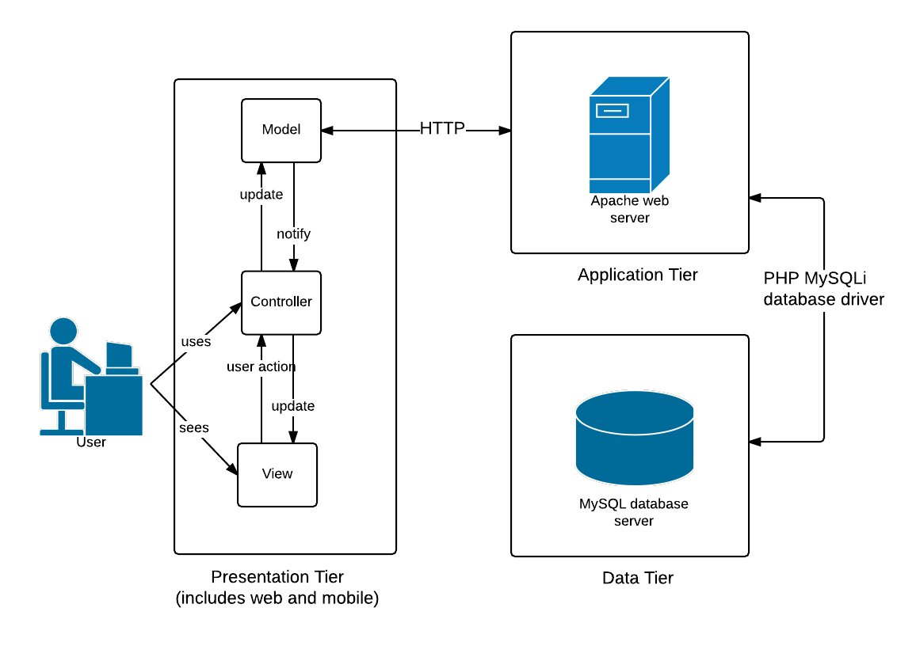

The logical aspect of the system is based on a repository architecture where the User Management Subsystem and the Event Creation Subsystem are the two subsystems on which the other subsystems are based on. With this architecture, the two main subsystems can be built first and the rest of the subsystems can be added in later prototypes of the system.

The nine subsystems of the Event Organizer are:

* User Management Subsystem that manages user profiles and access rights.
* Paper Management Subsystem that manages paper submissions, deadlines, sorting, filtering and storage.
* Paper Review Subsystem that manages reviewer requests, provides features for review procedures and protocols, and tracks reviews of papers.
* Event Management Subsystem that allows the creation of events, choosing of venues and setting of ticket prices.
* Venue Management Subsystem that allows venue building via a “room builder” feature.
* Event Logistics Subsystem that manages the various resources such as microphones and projectors during an event, and allow users to specify meal preferences.
* Ticketing and Payment Subsystem that allows users to purchase tickets.
* Analytics and Tracking Subsystem that tracks various aspects of the system such as the demographics of the event attendees and produces financial reports of events.
* In-house Event Subsystem that contains timetables of events, provides venue maps, facilitates check-in and sends post-event questionnaires to event attendees.

A graphical representation of the logical system architecture is shown below: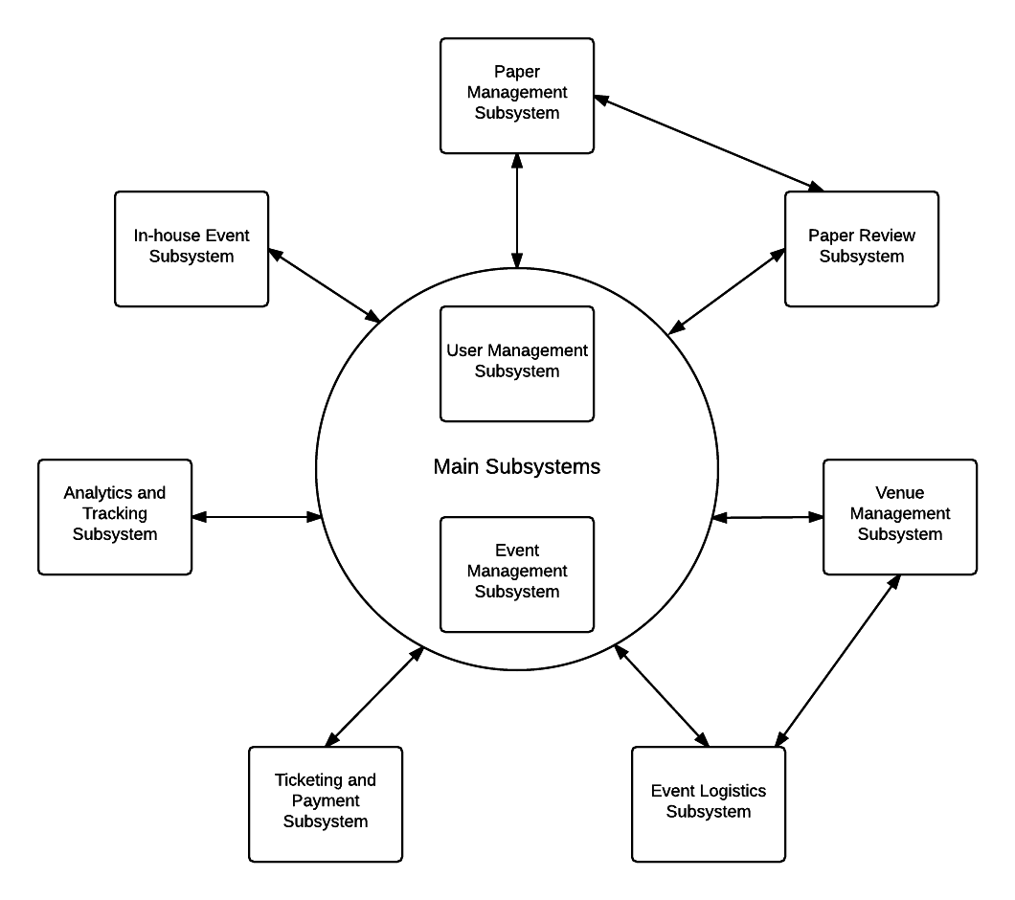

# Sub-system Relationship and Interaction Diagram

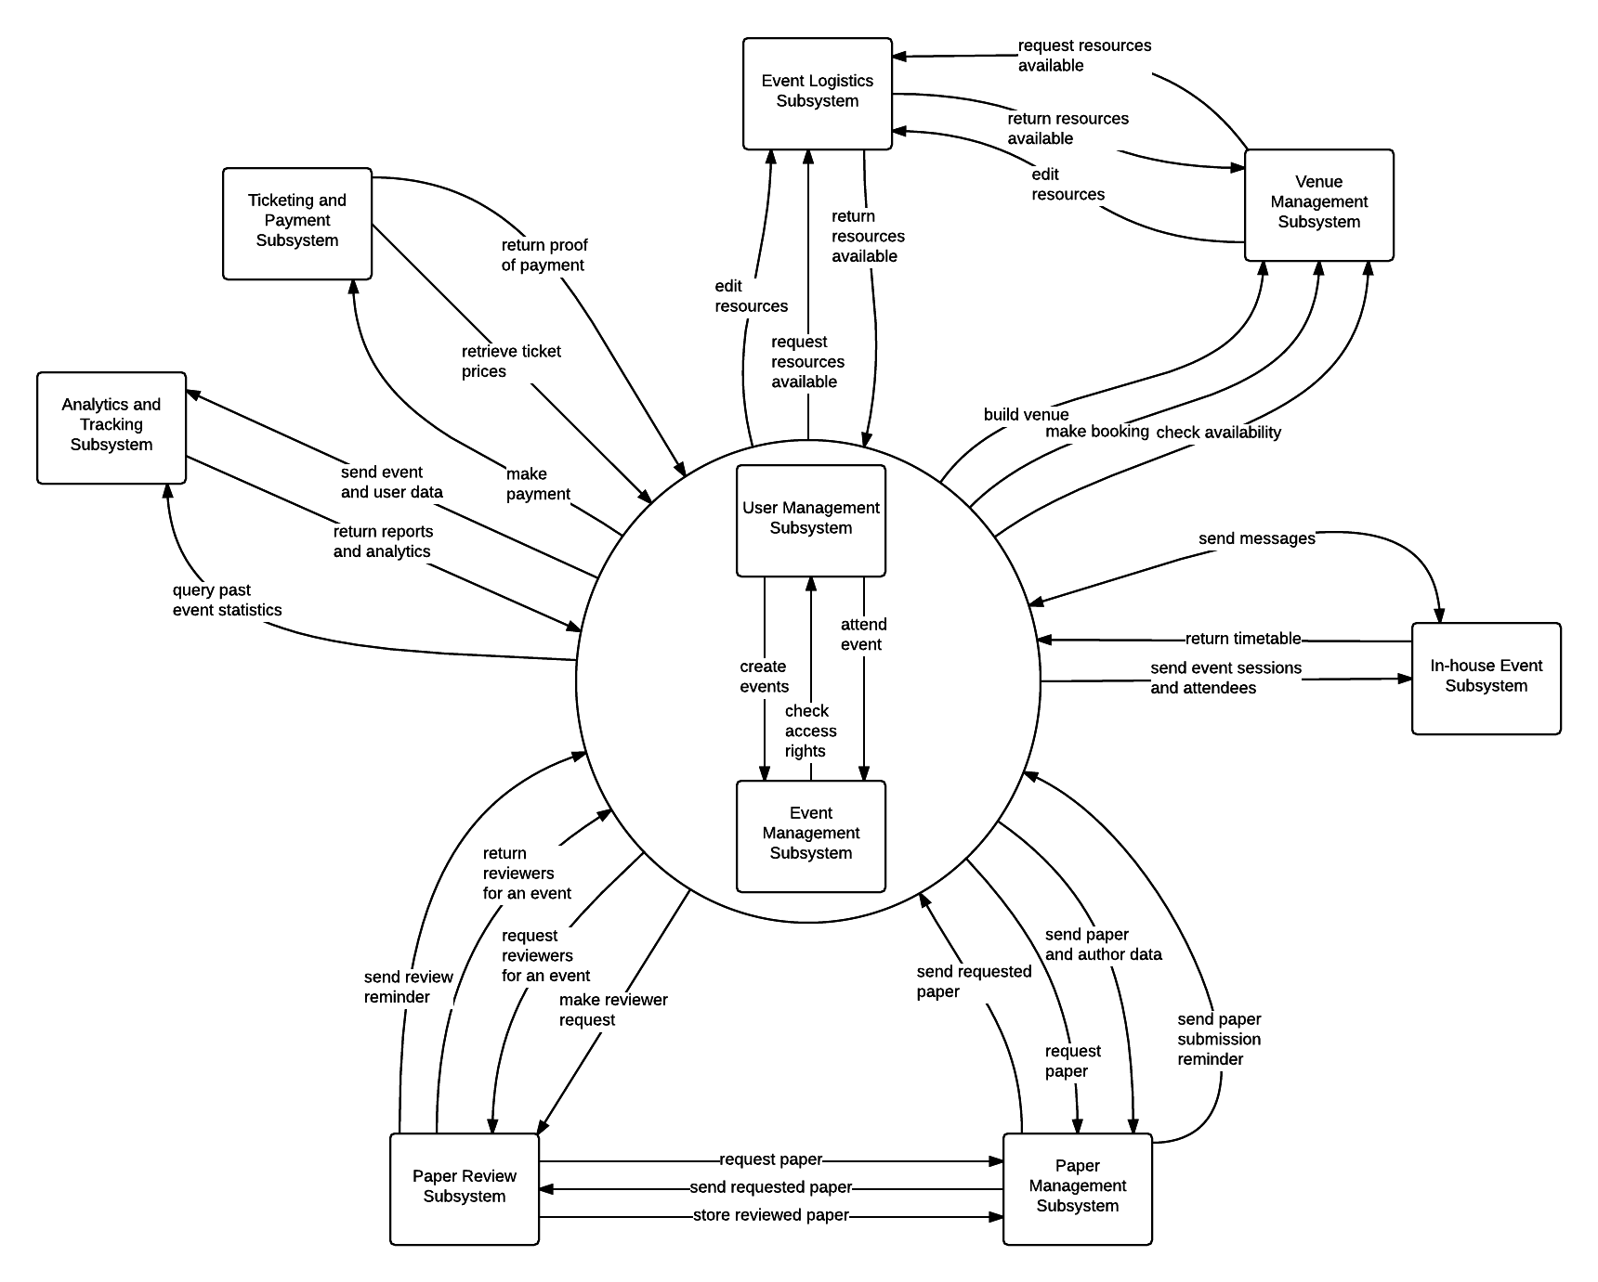The diagram below describes the interaction and relationships between the 9 subsystems of the Conf+ Conference Management System.

# System Flows

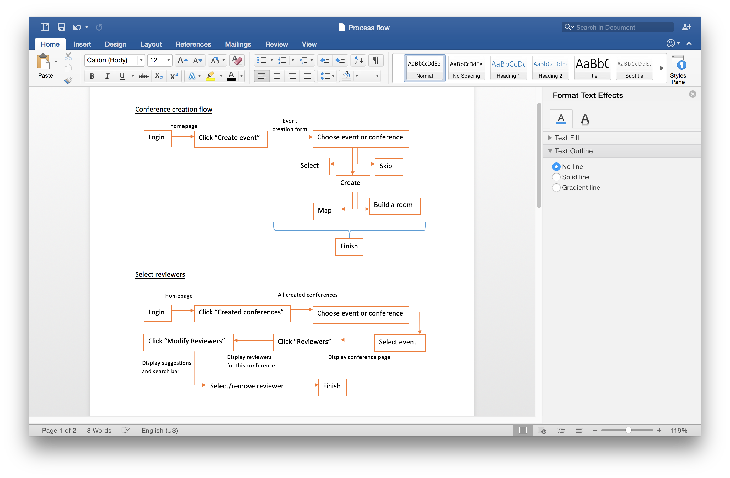



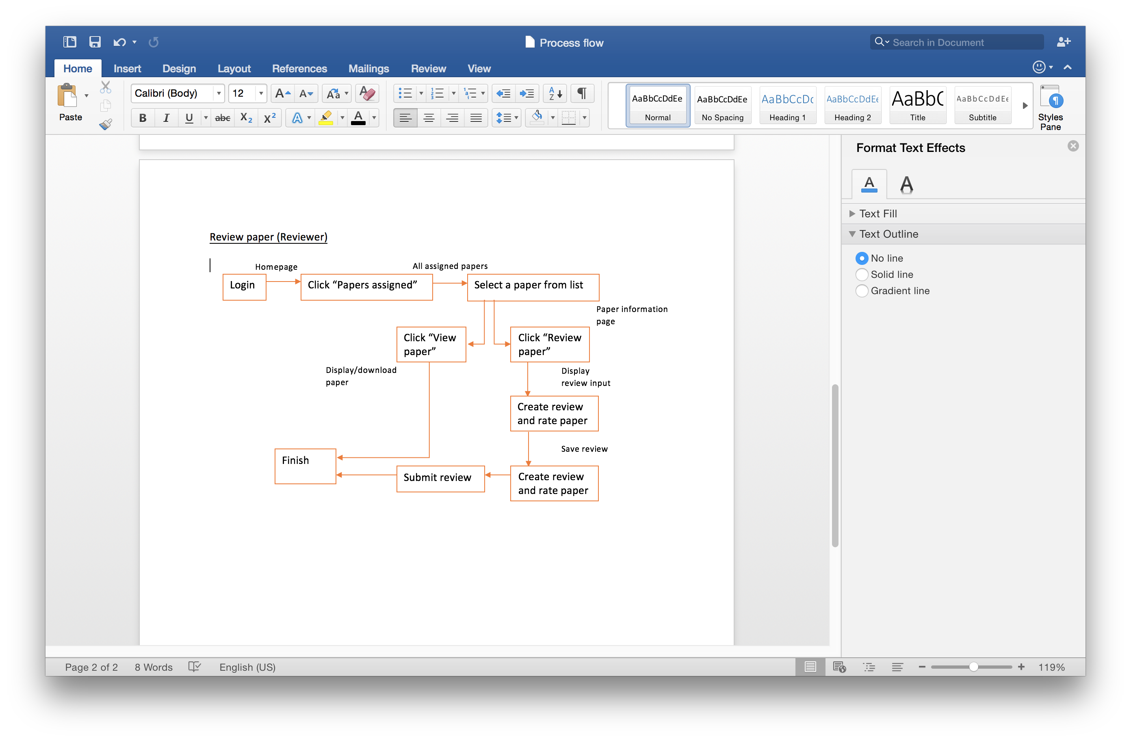

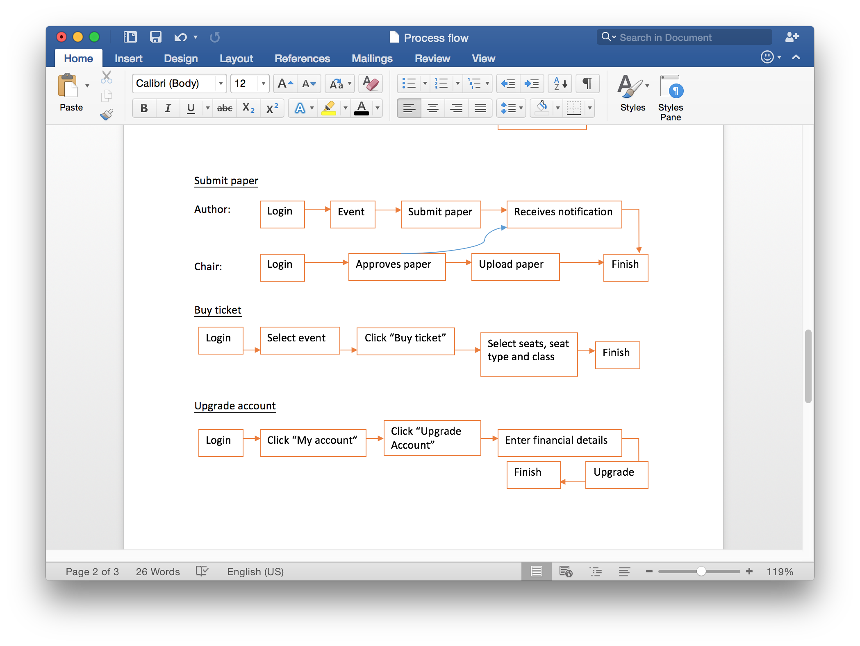

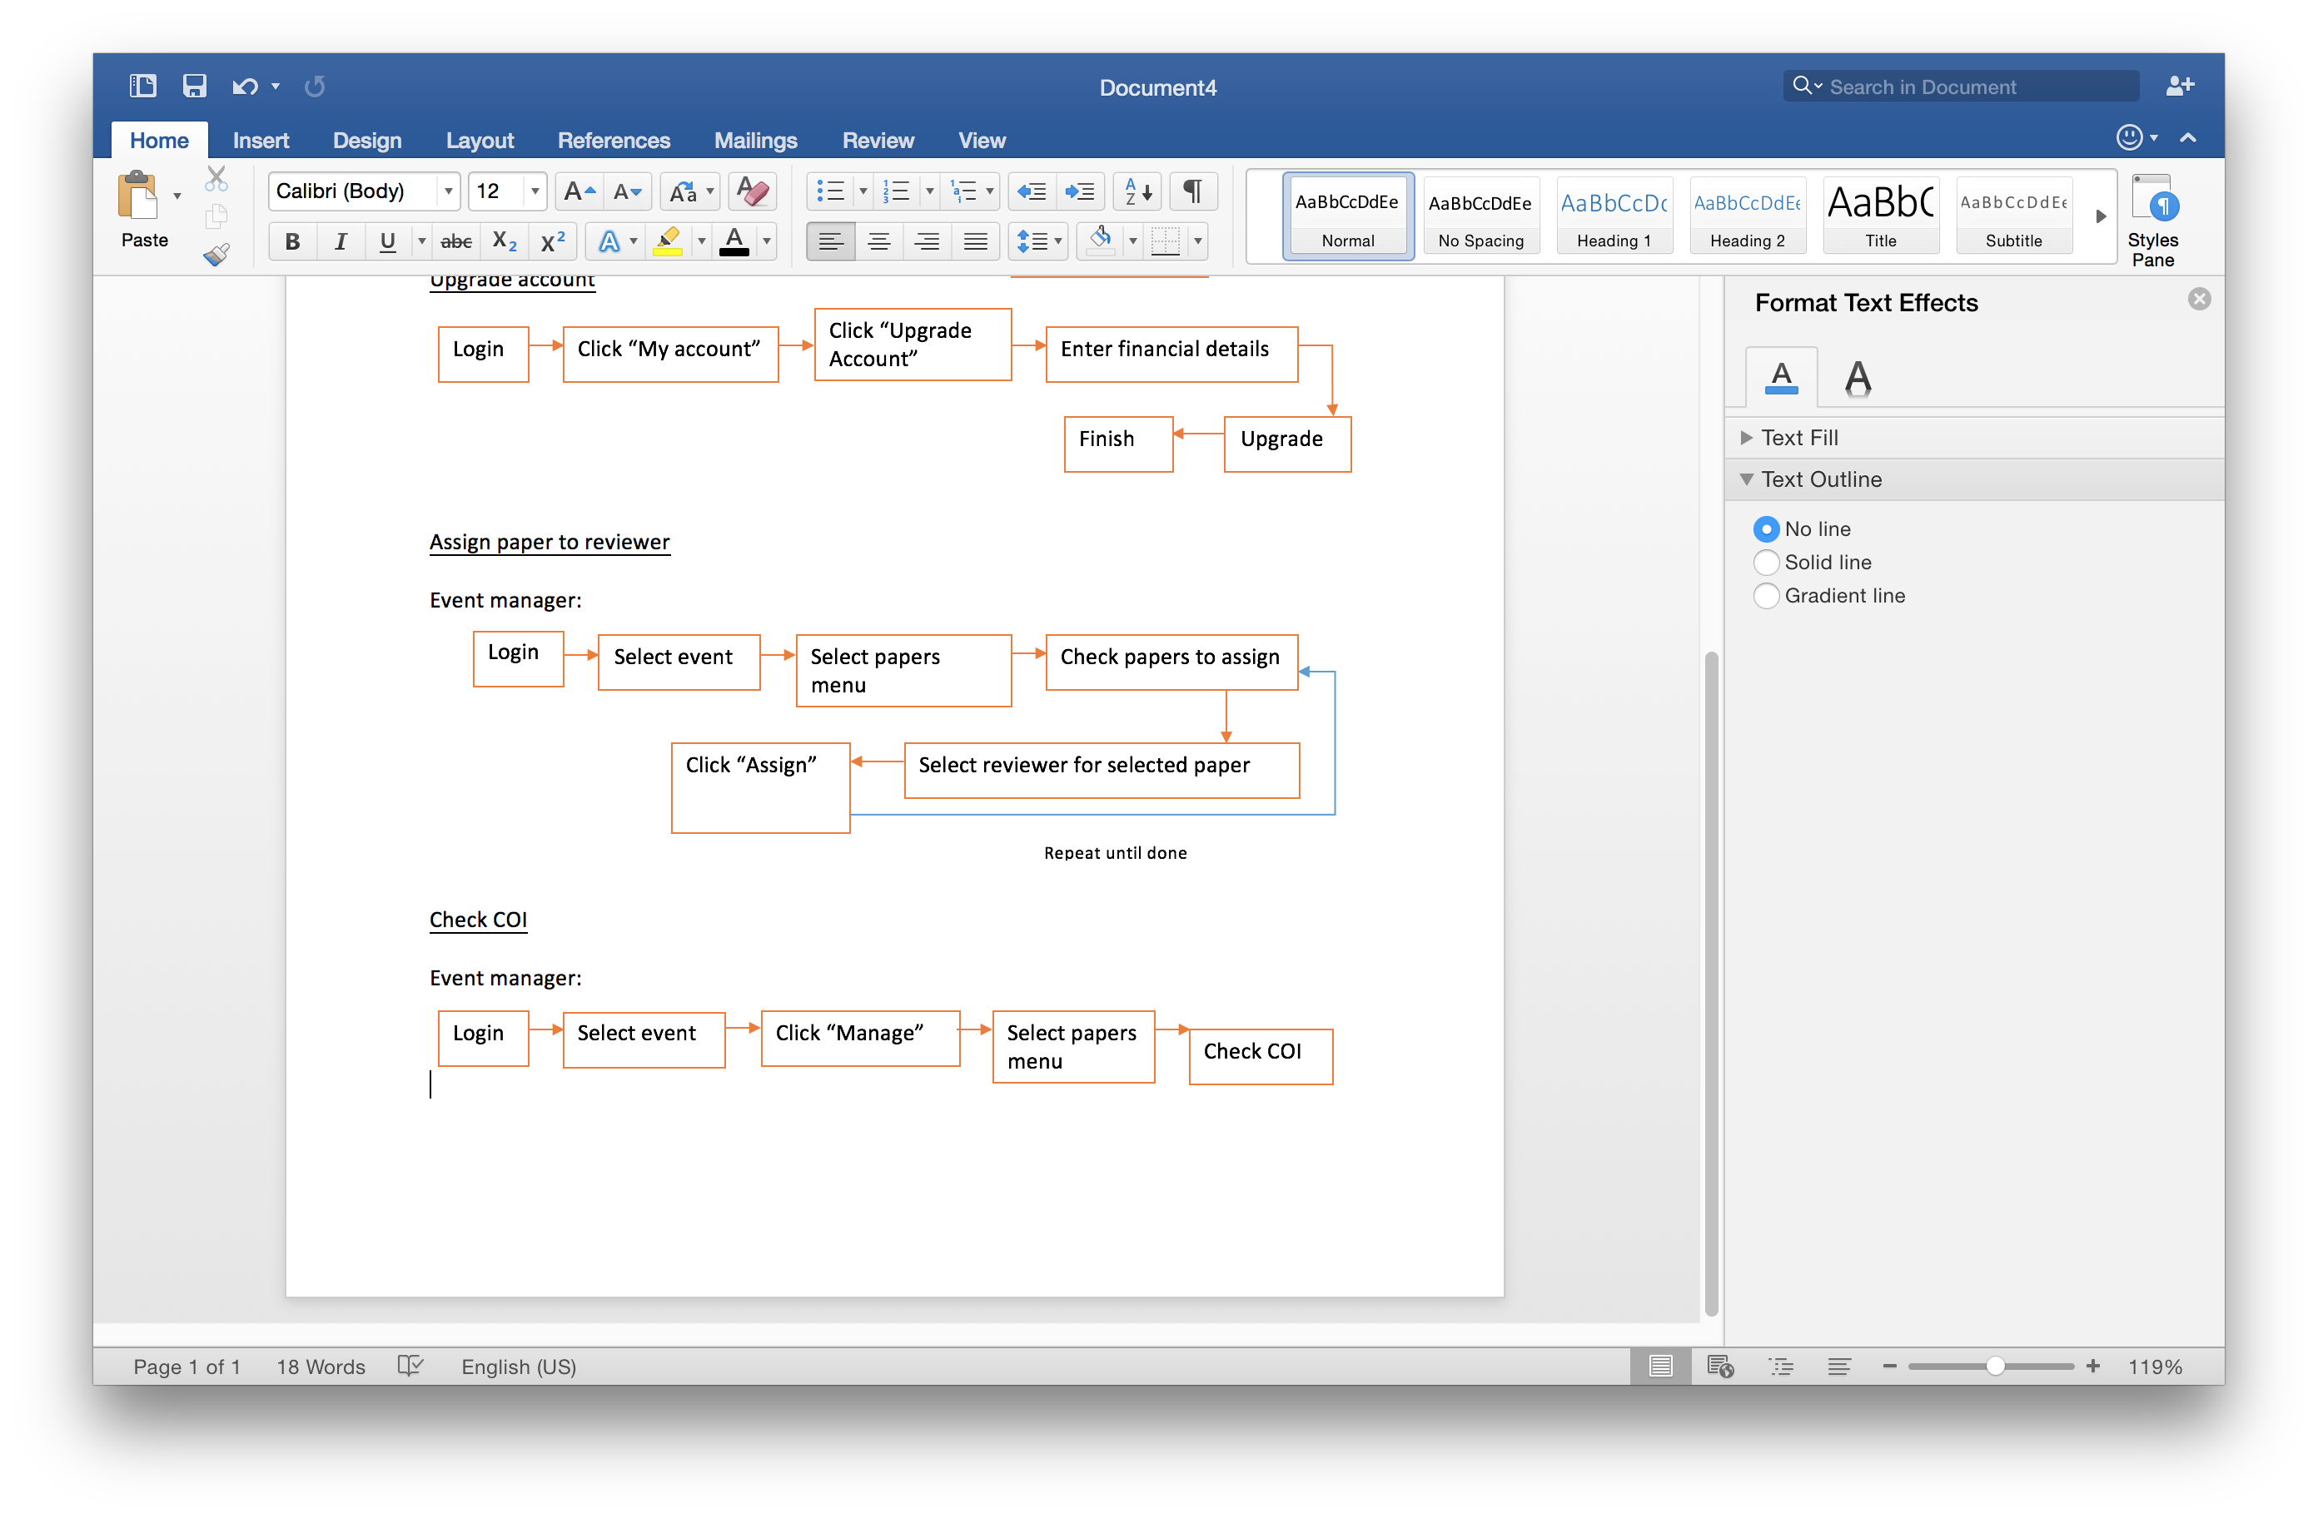

# System User Interface Design

## Website Design

**Header**

The header displays the Conf+ logo, a search bar to search for events or conferences and the user’s account panel. The user’s account panel will display the profile picture and “My account” button, that allows user to navigate to their profile to view personal details as well as make changes. There is also a log out button for logging out. The design of header bar uses a turquoise shade that will be widely used in this website to create an interface that is easy on the eyes.

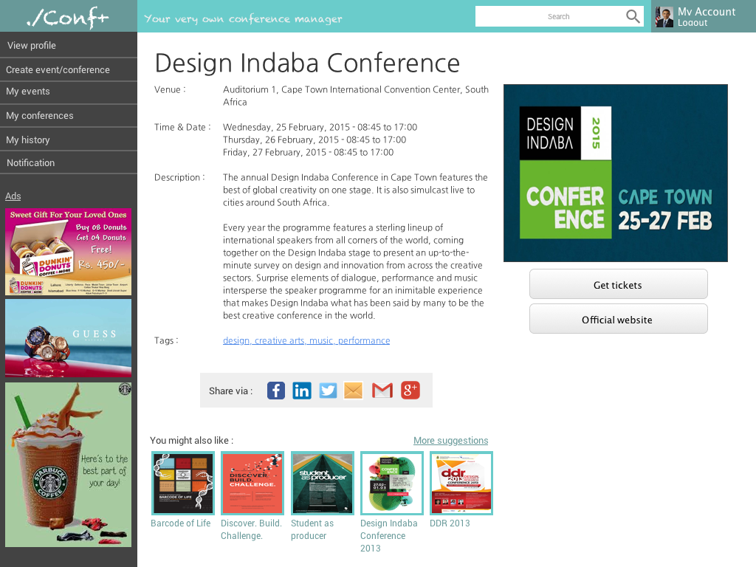

*Figure 1.1* Header bar for users who are logged in

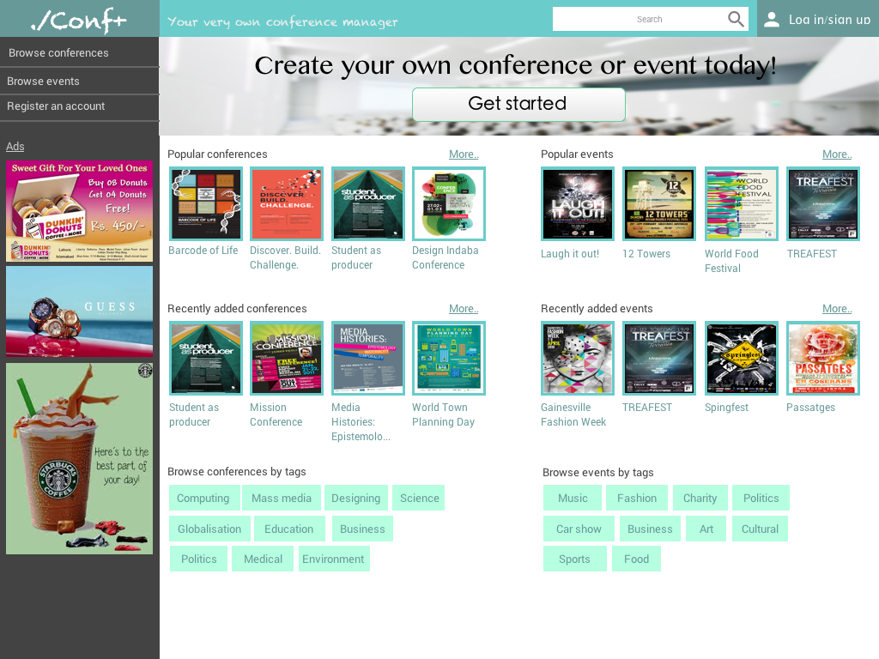

Figure 1.2 Header bar for guests

**Side menu**

The side menu for guests and logged in users are distinctive from each other in terms of contents.





*Figure 1.3* Side menu for guests

The side menu for users who are not logged in provides limited options in contrast to users who are logged in.

*Figure 1.4* Side menu for logged in users

However, a logged in user sees a side menu with tailored options that allows them to view personal information and histories. For instance, “View profile” option navigates to a page containing user’s personal details, “My events” or “My conferences” option navigates to a page where information of the user’s attending events or conferences will be displayed, “My history” shows user’s attended events or conferences, and “Notification” is where user can be notified about event updates, event invitation, paper review requests etc. To “Create event/conference” the user will need to have an upgraded account, or the page will just simply provide an upgrade option.

**Page content**

Page content varies depending on the page and its elements, however the general page design consists of white backgrounds, simple dark grey text and hints of turquoise to create aesthetically pleasing interface. In order to adhere to design consistency, the color schemes and arrangements page elements are similar.

The guest main page is topped with a call to action (CTA) and a quick start button to guide users through the system and option sign up for an account. This page is filled with popular conferences and events, recently added conference and events list, conference and event tags to make browsing convenient and accurate.



*Figure 1.5* Guest main page

When the user logs in, the main page is built with elements that is tailored for the user based on his/her history. For example, the user receives notification from events that they are going to attend, reminders on upcoming events or deadlines (paper submission and review), manage the user’s own events or conferences, and also recommended events and conferences that may match the user’s interest analyzed from user’s history. Browsing by tags are also displayed here for convenient event/conference searching.

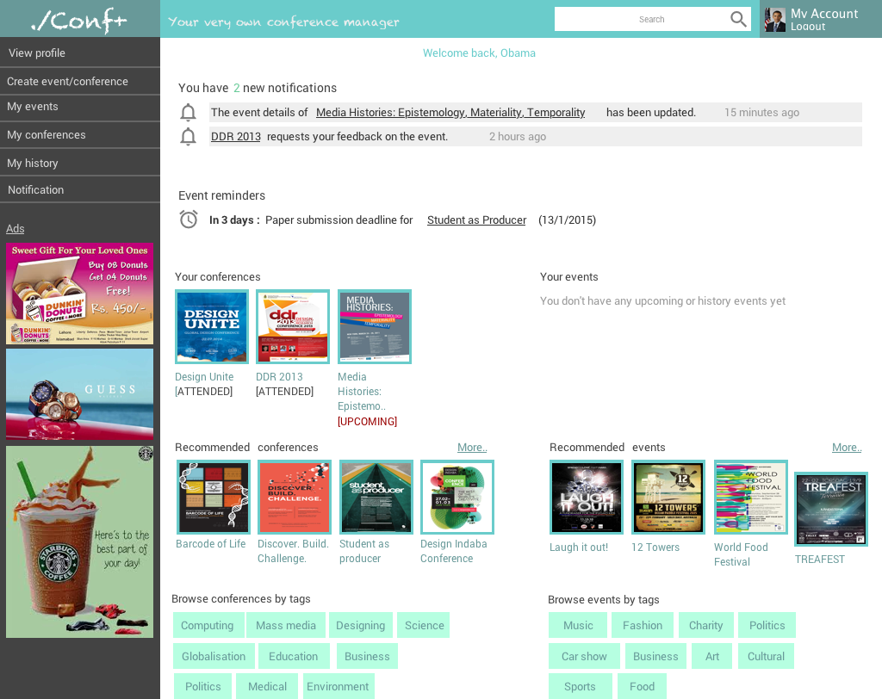

*Figure 1.6* User main page

Lastly, the event/conference page is made up of event details, event poster, get tickets or go to event/conference official website buttons, related tags, event/conference sharing methods (e.g. Facebook, LinkedIn, Twitter and so on) and also similar events/conferences recommendations.



## Mobile Design

The mobile version of this system mainly focuses on event attendees, and their interaction between each other, or interaction with organizers. The designs displayed here are merely prototypes, and will be further developed.

**Login page**

The login page is the pop up page when an application is launched, for users who are using the app for the first time, or have not logged in. They can either log in with their own created account, or choose to log in via Facebook or LinkedIn. Users who have forgotten their passwords can get help from the “forgot password” link, or sign up for an account if they have not done so. User who failed to log in will not be able to utilize the application.

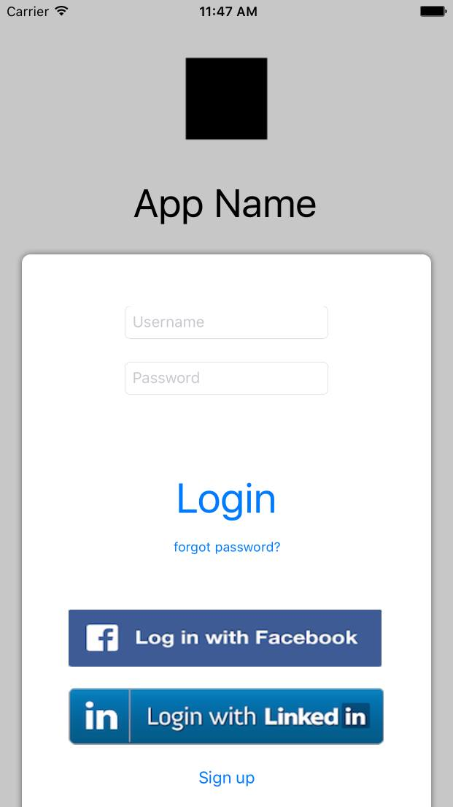

**User profile**

The user profile shows the user’s name and email, allowing them to edit details with the Edit button on the right top corner of the screen. Apart from that, there are settings for users to customize the application by changing language settings, to view their own payment history, or log out from their profile.

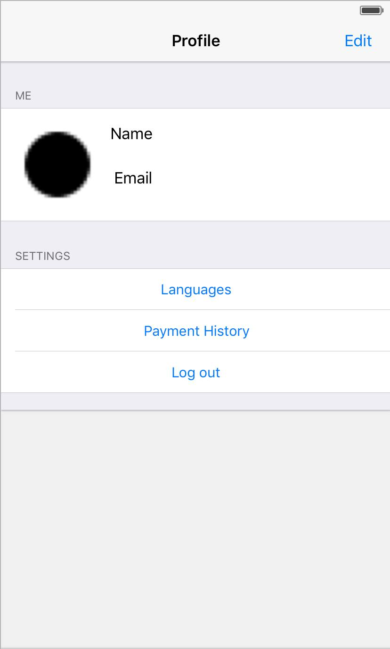

**Explore events**

Displays a list of events containing event name and event dates. By clicking on any of this cells will navigate to the event main page.

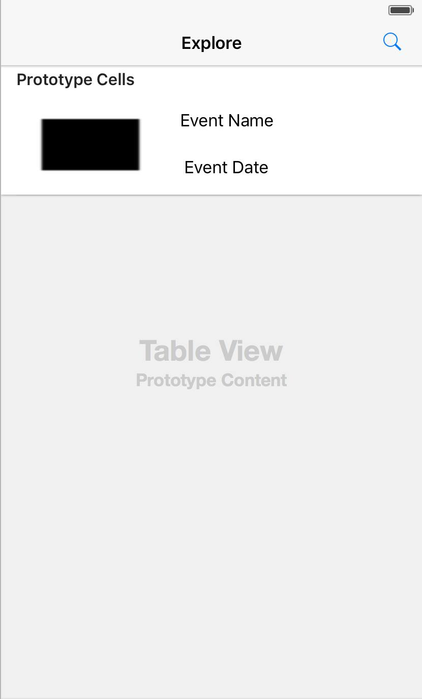

**Event homepage**

The event homepage contains icons that navigates to pages containing event information such as timetable for event programs, messages, location of the event, event security, event profile, or exit the event page.

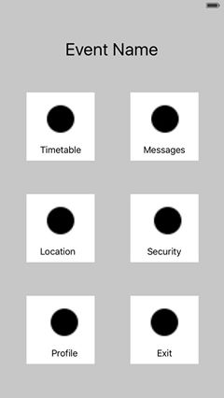

**Event profile**

This page displays the event profile that contains information that explains the event information including ticket details, and user details such as name and email, to allow organizer to check in attendees.

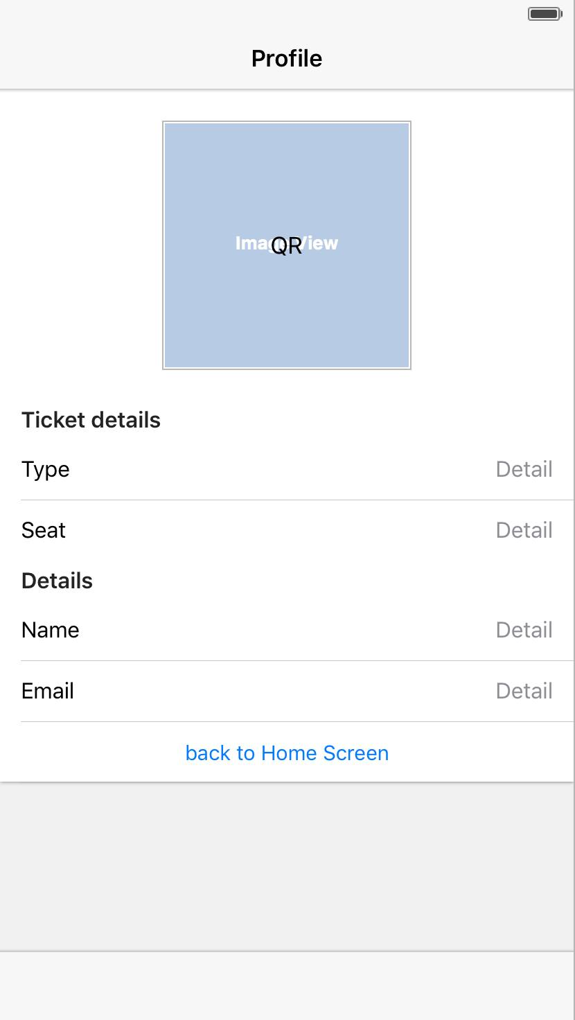

**Event details**

This is a page containing event details, containing event information such as event poster, event description (venue, time etc.) as well as the location aided with a map so that attendees can navigate themselves to the event location.

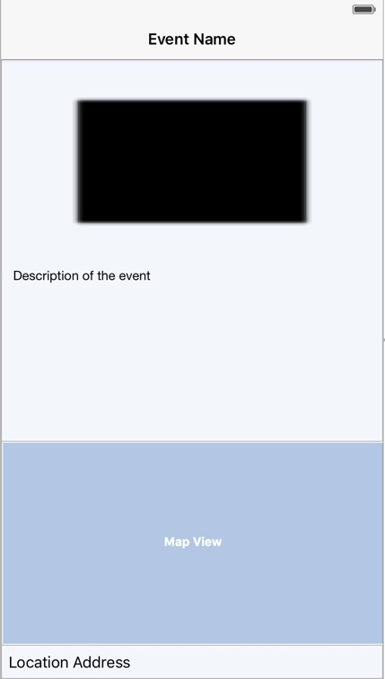

**Event with tickets**

This page is an extension from the event details page, navigated from tapping on buy ticket button. The page is made up of event details, and list of tickets available for the event. The user can select the quantity of tickets they would want to purchase here, and proceed to payment (if needed) page.

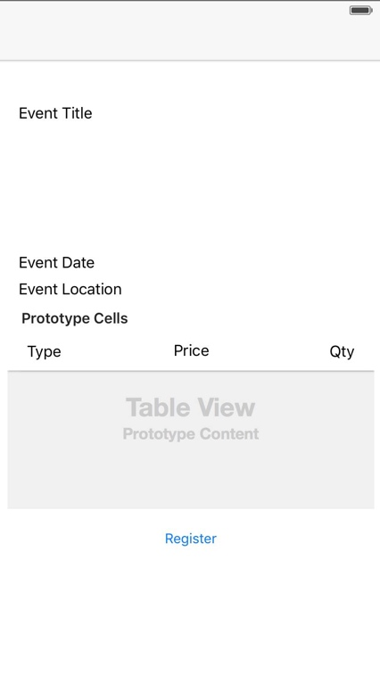

**Timetable**

The timetable is customized for user with their arrangement of talks or programs they want to attend to, making it easier for attendees to arrange their time while attending the event.

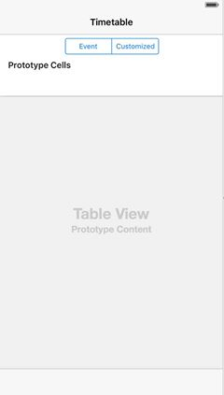

**Messages**

The messages page enables users to interact with one another, either communicate with other attendees of the event, or receive updates from organizer, or interact with the speaker when the talk is going on as a part of the event. The page displays the messages in a list containing the sender’s image, name, the message details and the date the message is sent.

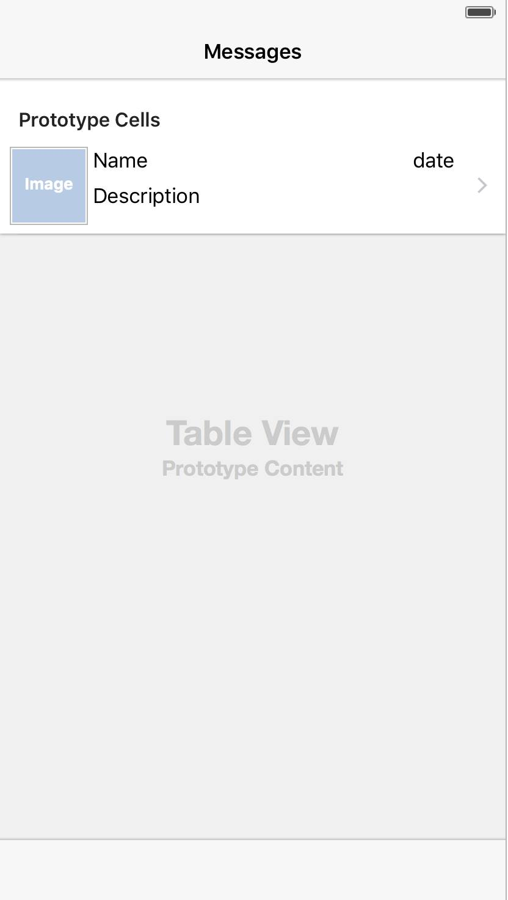

**Talks or programs**

A list of talks or programs offered by the event will be displayed in this page with the speaker’s picture or the talk poster, name of the speaker as well as ways to contact the speaker. The description of the talk will be shown at the bottom of the list item.

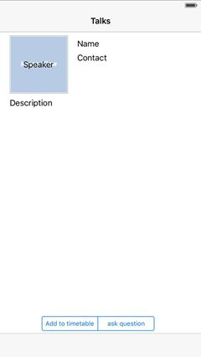

**Event history**

Tailored for users, shows their attended event history in a list. The cost label displays the amount the user spent on the ticket for this event.

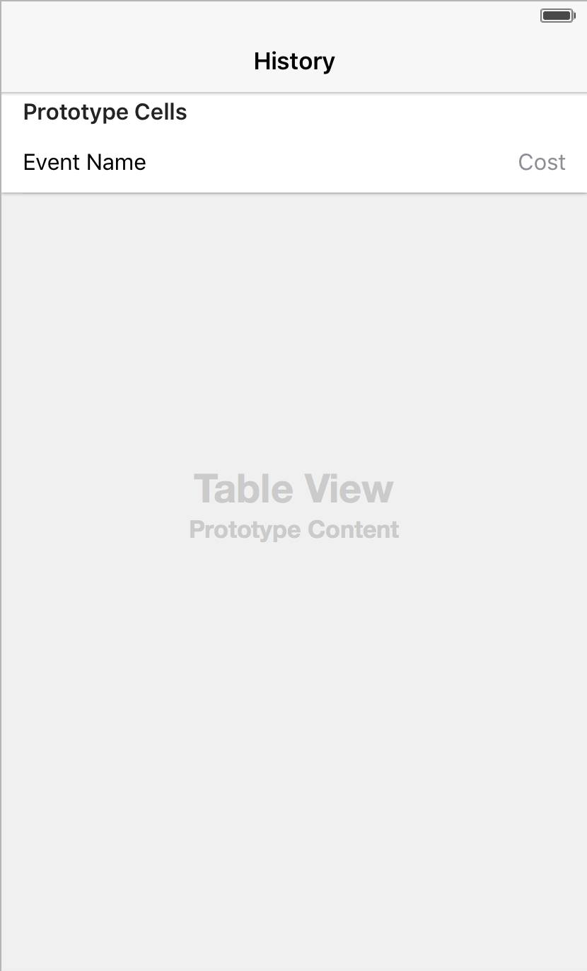

# Database Design

## ../../../../../Downloads/Database%20schema%20-%20New%20PageDatabase Schema

## Data Dictionary

Table: USER

|  |  |  |  |  |  |
| --- | --- | --- | --- | --- | --- |
| Field Name | Data Type | Key | Null | Default | Description |
| email | TEXT | PK | NO | NONE | User’s email address as the unique identifier |
| username | TEXT |  | YES | NULL | User name of user which made by themselves |
| password | TEXT |  | NO | NONE | Password of user |
| title | TEXT |  | YES | NULL | The title of user (Mr, Miss, Mrs, Doctor) |
| first_name | TEXT |  | YES | NULL | First name of user |
| last_name | TEXT |  | YES | NULL | Last name of user |
| dob | DATE |  | YES | NULL | Date of birth of user |
| Street | TEXT |  | YES | NULL | Street name of user’s address |
| city | TEXT |  | YES | NULL | City that user stay |
| state | TEXT |  | YES | NULL | State that user stay |
| county | TEXT |  | YES | NULL | User’s country |
| verified | BOOLEAN |  | YES | NULL | Whether the user account been verified by email |
| fb_id | NUMBER | CK | YES | NULL | User’s Facebook ID |
| linkedin_id | NUMBER | CK | YES | NULL | User’s LinkedIn ID |

Table: USER_TAG

|  |  |  |  |  |  |
| --- | --- | --- | --- | --- | --- |
| Field Name | Data Type | Key | Null | Default | Description |
| email | TEXT | PK, FK(User) | NO | NONE | User’s email address as the unique identifier, references User |
| tag_name | TEXT | PK | NO | NONE | Name of tag |

Table: MESSAGE

|  |  |  |  |  |  |
| --- | --- | --- | --- | --- | --- |
| Field Name | Data Type | Key | Null | Default | Description |
| sender_email | TEXT | PK, FK(User) | NO | NONE | Sender’s email address as the unique identifier, references User |
| receiver_email | TEXT | PK, FK(User) | NO | NONE | Receiver’s email address as the unique identifier, references User |
| content | TEXT |  | NO | NONE | Content of the message |
| date | DATE | PK | NO | NONE | The date, time of the message |

Table: BILLING

|  |  |  |  |  |  |
| --- | --- | --- | --- | --- | --- |
| Field Name | Data Type | Key | Null | Default | Description |
| email | TEXT | PK, FK(User) | NO | NONE | User’s email address as the unique identifier, references User |
| card# | INTEGER | PK | NO | NONE | Credit card number of user, unique identifier |
| card_type | TEXT |  | NO | NONE | Credit card type (MasterCard, VISA, American Express) |
| expiry_date | DATE |  | NO | NONE | Expiry date of credit card |

Table: PAYMENT

|  |  |  |  |  |  |
| --- | --- | --- | --- | --- | --- |
| Field Name | Data Type | Key | Null | Default | Description |
| email | TEXT | PK, FK(User) | NO | NONE | User’s email address as the unique identifier, references User |
| payment_id | INTEGER | PK | NO | NONE | Unique number that identify a payment |
| type | TEXT |  | NO | NONE | Payment type (ticket, upgrade) |
| amount | INTEGER |  | NO | NONE | Amount of a payment |
| payment_date | DATE |  | NO | NONE | Payment date |

Table: PAPER

|  |  |  |  |  |  |
| --- | --- | --- | --- | --- | --- |
| Field Name | Data Type | Key | Null | Default | Description |
| title | TEXT | PK | NO | NONE | Title of paper, unique identifier |
| publish_date | DATE | PK | NO | NONE | Publish date of paper, unique identifier |
| latest_sub_date | DATE |  | NO | NONE | The date that this paper was submitted |
| status | TEXT |  | NO | NONE | Status of paper (unreviewed, in-review, reviewed) |
| accept | BOOLEAN |  | YES | NULL | Wether the paper been accepted or not |
| url | TEXT |  | NO | NONE | url link of the paper |

Table: PAPER_TAG

|  |  |  |  |  |  |
| --- | --- | --- | --- | --- | --- |
| Field Name | Data Type | Key | Null | Default | Description |
| title | TEXT | PK, FK(Paper) | NO | NONE | Title of paper, unique identifier, references Paper |
| publish_date | DATE | PK, FK(Paper) | NO | NONE | Publish date of paper, unique identifier, references Paper |
| tag_name | TEXT | PK | NO | NONE | Name of tag |

Table: PAPER_AUTHORED

|  |  |  |  |  |  |
| --- | --- | --- | --- | --- | --- |
| Field Name | Data Type | Key | Null | Default | Description |
| email | TEXT | PK, FK(User) | NO | NONE | User’s email address as the unique identifier, references User |
| title | TEXT | PK, FK(Paper) | NO | NONE | Title of paper, unique identifier, references Paper |
| publish_date | DATE | PK, FK(Paper) | NO | NONE | Publish date of paper, unique identifier, references Paper |

Table: PAPER_REVIEWED

|  |  |  |  |  |  |
| --- | --- | --- | --- | --- | --- |
| Field Name | Data Type | Key | Null | Default | Description |
| email | TEXT | PK, FK(User) | NO | NONE | User’s email address as the unique identifier, references User |
| title | TEXT | PK, FK(Paper) | NO | NONE | Title of paper, unique identifier, references Paper |
| publish_date | DATE | PK, FK(Paper) | NO | NONE | Publish date of paper, unique identifier, references Paper |
| comment | TEXT |  | YES | NULL | Comment provided by reviewer |

Table: EVENT

|  |  |  |  |  |  |
| --- | --- | --- | --- | --- | --- |
| Field Name | Data Type | Key | Null | Default | Description |
| event_id | INTEGER | PK | NO | NONE | Unique identifier of an event |
| name | TEXT |  | NO | NONE | Name of an event |
| type | TEXT |  | NO | NONE | Type of an event |
| from_date | DATE |  | NO | NONE | Start date of an event |
| to_date | DATE |  | NO | NONE | End date of an event |
| description | TEXT |  | NO | NONE | Description of an event |
| url | TEXT |  | NO | NONE | The url link of an event |
| paper_deadline | DATE |  | YES | NULL | The final deadline of paper submission |

Table: EVENT_TAG

|  |  |  |  |  |  |
| --- | --- | --- | --- | --- | --- |
| Field Name | Data Type | Key | Null | Default | Description |
| event_id | INTEGER | PK, FK(Event) | NO | NONE | User’s email address as the unique identifier, references Event |
| tag_name | TEXT | PK | NO | NONE | Name of tag |

Table: TICKET_TYPE

|  |  |  |  |  |  |
| --- | --- | --- | --- | --- | --- |
| Field Name | Data Type | Key | Null | Default | Description |
| event_id | INTEGER | PK, FK(Event) | NO | NONE | Event id as the unique identifier, references Event |
| name | TEXT | PK | NO | NONE | Name of ticket (early bird, normal, free, etc) |
| price | FLOAT |  | YES | NULL | Ticket price |
| description | TEXT |  | NO | NONE | Description of the ticket |
| start_date | DATE |  | NO | NONE | The start date of ticket sold |
| end_date | DATE |  | NO | NONE | The end date of ticket sold |
| quantity | INTEGER |  | NO | NONE | The quantity of this ticket type |
| num_purchased | INTEGER |  | YES | 0 | The number of ticket purchased |

Table: EVENT_ATTENDED

|  |  |  |  |  |  |
| --- | --- | --- | --- | --- | --- |
| Field Name | Data Type | Key | Null | Default | Description |
| email | TEXT | PK, FK(User) | NO | NONE | User’s email address as the unique identifier, references User |
| event_id | INTEGER | PK, FK(Event) | NO | NONE | Unique identifier of an event, references Event |
| role | TEXT | PK | NO | NONE | The role of the user in this event |

Table: SESSION

|  |  |  |  |  |  |
| --- | --- | --- | --- | --- | --- |
| Field Name | Data Type | Key | Null | Default | Description |
| event_id | INTEGER | PK, FK(Event) | NO | NONE | Unique identifier of an event, references Event |
| title | TEXT | PK | NO | NONE | Title of the session in an event, unique identifier |
| speaker_email | TEXT | PK, FK(User) | NO | NONE | Speaker’s email address as the unique identifier, references User |
| start_time | DATE |  | NO | NONE | Start time of session |
| end_time | DATE |  | NO | NONE | End time of session |

Table: SESSION_ATTENDED

|  |  |  |  |  |  |
| --- | --- | --- | --- | --- | --- |
| Field Name | Data Type | Key | Null | Default | Description |
| email | TEXT | PK, FK(User) | NO | NONE | Attendee’s email address as the unique identifier, references User |
| event_id | INTEGER | PK, FK(Session) | NO | NONE | Unique identifier of an event, references Session |
| title | TEXT | PK, FK(Session) | NO | NONE | Title of the session in an Session, unique identifier, references Session |
| speaker_email | TEXT | PK, FK(Session) | NO | NONE | Speaker’s email address as the unique identifier, references Session |

Table: VENUE

|  |  |  |  |  |  |
| --- | --- | --- | --- | --- | --- |
| Field Name | Data Type | Key | Null | Default | Description |
| venue_id | INTEGER | PK | NO | NONE | Unique identifier of a venue |
| name | TEXT |  | NO | NONE | Name of venue |
| type | TEXT |  | NO | NONE | Type of Venue (stadium, building) |
| has_room | BOOLEAN |  | NO | NONE | Whether the venue has rooms |
| street | TEXT |  | NO | NONE | Street name of venue |
| city | TEXT |  | NO | NONE | City name of venue |
| state | TEXT |  | NO | NONE | State of venue |
| country | TEXT |  | NO | NONE | County of venue |
| longitude | FLOAT |  | NO | NONE | Longitude of venue |
| latitude | FLOAT |  | NO | NONE | Latitude of venue |

Table: ROOM

|  |  |  |  |  |  |
| --- | --- | --- | --- | --- | --- |
| Field Name | Data Type | Key | Null | Default | Description |
| venue_id | INTEGER | PK, FK(Venue) | NO | NONE | Unique identifier of a venue, references Venue |
| name | TEXT | PK | NO | NONE | Name of room, unique identifier |
| type | TEXT |  | NO | NONE | Type of room |
| capacity | INTEGER |  | NO | NONE | Capacity of room |

Table: RESOURCE

|  |  |  |  |  |  |
| --- | --- | --- | --- | --- | --- |
| Field Name | Data Type | Key | Null | Default | Description |
| venue_id | INTEGER | PK, FK(Room) | NO | NONE | Unique identifier of a venue, references Room |
| room_name | TEXT | PK, FK(Room) | NO | NONE | Name of room, unique identifier, references Room |
| name | TEXT | PK | NO | NONE | Name of resource, unique identifier |
| type | TEXT |  | NO | NONE | Type of resource |
| number | INTEGER |  | NO | NONE | Number of resource |

# Third-party Libraries

* Laravel – Based on PHP, Laravel is a web application framework that is based on the Model-View-Controller architectural pattern. It simplifies functions such as database access and query building. Laravel is a popular PHP framework which ensures that help resources are available online.

Reference: http://laravel.com/

* PHPUnit – A unit testing framework designed for testing PHP scripts and classes. We chose this testing framework because has built-in support with Laravel which makes it an ideal choice for testing our PHP scripts.

Reference: https://phpunit.de/; http://laravel.com/docs/5.1/testing

* jQuery – A JavaScript library that simplifies client-side JavaScript programming. jQuery has many in-built features, including shorthand Ajax requests to simple animations, that reduce programming time significantly.

Reference: https://jquery.com/

* Bootstrap – An open-source front-end framework that is designed to build websites and web-applications quickly. It integrates HTML, CSS and JavaScript into one coherent framework that is supported the major web browsers. It also has good support for websites built for mobile devices due to its responsive web design.

Reference: http://getbootstrap.com/

* Amazon Web Services (AWS) – AWS provides many different web services that range from networking to database services. The Event Organizer is hosted on Amazon EC2 with the MySQL database on Amazon RDS. This is supported by Amazon S3 which is the storage services of AWS.

Reference: https://aws.amazon.com/

* Mailchimp – An email service that Conf+ will use to send confirmation emails to users and reminder emails to event attendees.

Reference: http://mailchimp.com/

* iRedMail – An open-source mail server software that will be used as the mail server of Conf+. It will be installed on the AWS EC2 web service.

Reference: http://www.iredmail.org/

* CocoaPods – This technology is a library of Objective-C libraries. It acts as a dependency manager for both Swift and Objective-C applications. This facilitates code reuse and reduces the amount of time spent in writing and testing code.

Reference: https://cocoapods.org/

# Testing Plan

Testing is generally considered a part of the development lifecycle that is performed at a late stage but in reality it is a phase which can start at the very beginning of the SDLC. As we are not using a Test Driven Development Methodology we will not be performing testing before we write code. We are using a RaPID Development Methodology (rapid prototyping and iterative development) therefore we will perform testing at the end of each iteration.

## Testing inaccuracy

All testers either have optimistic inaccuracy or pessimistic inaccuracy. For the scope of this project in the limited time frame we have and the large scale, we will be inclined to prefer an optimistic inaccuracy approach. Pessimistic inaccuracy is when developers cannot prove that the software achieves 100% correctness therefore they don't accept the software. Optimistic inaccuracy is when developers cannot detect any faults through thorough testing and because of this they are happy even thought they cannot prove 100% correctness. This is generally the case with most systems that are not safety critical like a conference/event management system.

## Techniques

It is prevalent that not one single technique for testing is optimal. A combination of testing techniques increases testing effectiveness. Each testing technique has a different purpose and tradeoffs.

**Acceptance testing** will be done toward the mid-late stages of development. This will be done by doing alpha testing. Alpha acceptance testing is when the company acquires individuals to use the product under a controlled environment.

When **alpha testing** is done, the developer runs the test by having an individual who is likely to use the system. We introduce them to the product and lay out a bunch of functionalities that the system can perform. For example, book a ticket to "UOW The Movie" with the user's preferences. Rather than telling the individual to click this a particular button and induct them through the process by telling them the goal they wish to achieve we can observe their behaviour and their interaction with the interface. If all goes to plan the interface should be intuitive (speak for itself). If the user appears confused or takes too long to perform the task within the limits set by the non-functional requirements, improvements should be made to the system, given the project is running smoothly and we are able to complete the project in time. In outlining this it is important to note that this project/assignment has a fixed due date unlike real life projects, which although they have a due date, are generally flexible to allow small desirable items to be implemented/checked/testing, etc. Clients are generally willing to wait extra time in order to improve aspects such as usability. As we are using RaPID we will be performing rapid prototyping of the user interface. It will not be necessary to perform alpha testing on every single rapid prototype (assuming that part of the code is function). We feel it is best to select one stage when we will perform alpha testing and based on feedback we will perform more changes to the GUI (continue rapid prototyping of GUI) until we have satisfied all issues detected. We should then run alpha testing on the new build with the existing testers which had issues using the software and a new group of individuals.

## Future development

The system we are designing is not designed solely to achieve 100% functionality. The requirements have been designed so that all Core, Main and possibly some Stretch requirements are achievable within the time given, team experience and available equipment. The Stretch goals and Dream goals have been implemented so that if the system can be further developed after the project has been completed. If further perfective maintenance or system modifications are performed, further tests should be executed to ensure the quality of the system.

## Sensitivity

We aim to have all testing at a high degree of sensitivity. Sensitivity in testing is an Analysis and Testing Principle that ensures that the outcome of a test is consistent. This is crucial for us as our development team does not want to have test cases that passes a majority of the time but fails only once. Assuming the same input (a test case), the output should be the same each time (a pass or fail of the test case or the same data output/effect).

## Assertion

For the web end we are using PHP which come with the ability to use assertions. This will become useful when we perform testing. It is important to note that there is different syntax for different versions of PHP so all developers must be using the same version of PHP.

For iOS we can also use assertions to test the mobile application. iOS has a NSAssertionHandler object which can be used for testing.

# Test cases

The test case specification will be developed at the end of the first iteration.

A test case specification must be satisfied by at least one test case.

Each test case must have specified input, execution conditions and pass/fail criterion. They should be outlined if they are for the Website or for the iOS app.

The diagram below shows the process of how test cases can be formed from requirements.

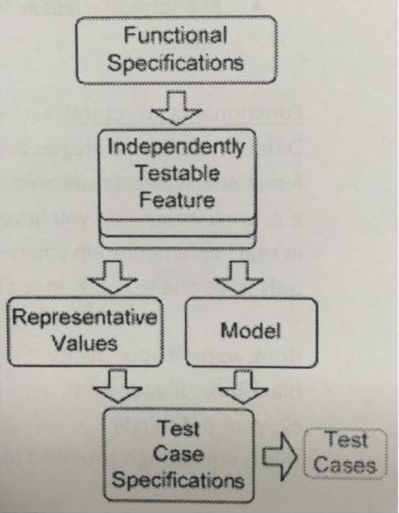

## Black Box and White Box Testing

Black box testing, also known as functional testing, is testing in comparison to the requirements (SRS). White box testing, also known as structural testing, is the testing of the actual code itself.

The methods of performing black box testing are unit, integration, system and regression testing. We should aim to perform all these types of testing on core parts of the system. The methods for performing white box testing are unit testing and integration testing which we should also aim to cover.

Covering both black box and white box testing is optimal and the best way to achieve black box and white box testing is to do black box runtime monitoring first of all. Once this is done, the covered branches must be identified and test cases should be created for these branches.

## Testing tools

* Jenkins  
  Jenkins is a tool which we can use for testing. It was originally developed for testing web apps but since has become the industry standard for open source iOS testing. It is therefore suitable for our project as we can use it for both the website and the iOS application.
* Xcode for iOS  
  XCode has built in code coverage tools. static analyser and a linter tool. Linting is the process of running a program that will analyse code for potential errors. It should enforce styles and conventions for the chosen language.
* SwiftLint is one linting tool that can be used for swift
* XCTest framework  
  UI testing framework for iOS apps. It also allows us to take screenshots at each stage throughout the application
* Unit Testing  
  XCode has built in unit testing. Examples and guides can be found on iosunittesting.com. We should be able to perform unit testing on both Objective C and Swift code at each iteration.

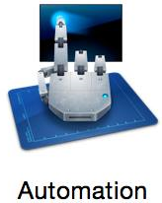

* UIAutomation  
  UIAutomation is a tool within XCode's instruments. We have found a useful guide to beginning automated testing in XCode. Another tool we could use is Frank which allows structured text test such as acceptance/requirements tests to be executed against the iOS application.
* Core Animation  
  Measures application graphics performance as well as CPU usage of a process via time profiling.

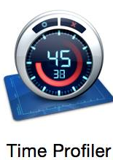

* Time Profiler  
  Performs low-overhead time-based sampling of processing running on the system's CPU.
* Leaks  
  Measures general memory usage, checks for leaked memory and provides statistics on object allocations by class as well as memory address histories for all active allocations and leak blocks.
* Energy Diagnostics  
  Diagnostics regarding energy use as well as basic on/off state of major device components.
* Core Data  
  Traces Core Data file system activity including fetches, cache misses and saves.
* Code Coverage  
  XCode had the ability to gather code coverage data which the selection of a check box. Other possibilities are GCOV, Slather and coveralls.io. coveralls is a web service that can be used for C/C++, D, GO, Haskell, JAVA, Javascript and node, Julia, LUA, .NET, PHP, Python, R, Ruby/Rails, Scala, Objective C and OCAML for code coverage. It would therefore be suitable to test the code coverage of PHP and Objective C code. This is free for open source projects on Github or BitBucket. For swift code coverage SwiftCov is a possible tool.
* Payment Research  
  Based on research we have conducted it is seem that collis test tool is the industry standard for mobile payment testing. This would be good but most likely unattainable as it is paid testing software which is most likely expensive.   
    
  We have found this link on the PayPal developer sight which uses V.Zero which accepts, PayPal, credit card, apple pay, android pay, bitcoin and venmo payments. They have an PayPal SDK and a library for iOS called Braintree.
* Fastlane  
  Fastlane can be useful during release. It is a tool that allows deployment pipelines to be run on different environments that helps unify and automate the process. It has integration with CocoaPods and Jenkins and is open source. A list of tools Fastlane provides is shown below.

